Practical 12

Part A:
Aim:
1. Word frequency: split a paragraph into words, count each in a HashMap, and print the words sorted by frequency (highest first) using a Comparator.

Code:
WordFrequency.java

import java.util.*;

public class WordFrequency {
public static void main(String[] args) {
String paragraph = "Java is easy and Java is powerful. "
+ "Java is popular and easy to learn.";

// Normalize case and remove punctuation
String cleaned = paragraph.toLowerCase()
.replaceAll("[^a-z0-9\\s]", "");

String[] words = cleaned.trim().split("\\s+");

// Count word frequencies
Map<String, Integer> frequency = new HashMap<>();

for (String word : words) {
frequency.put(word, frequency.getOrDefault(word, 0) + 1);
}

// Sort entries by frequency descending, then word ascending
List<Map.Entry<String, Integer>> entries =
new ArrayList<>(frequency.entrySet());

entries.sort(
Comparator
.<Map.Entry<String, Integer>>comparingInt(
Map.Entry::getValue)
.reversed()
.thenComparing(Map.Entry::getKey)
);

System.out.println("Word Frequencies (Highest First):");
for (Map.Entry<String, Integer> entry : entries) {
System.out.println(entry.getKey() + " : " + entry.getValue());
}
}
}

Output:
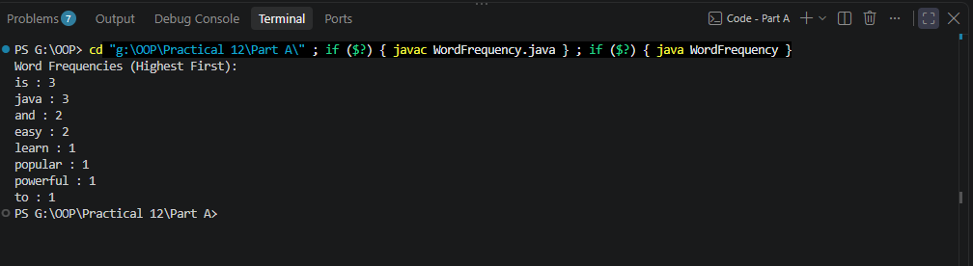

2. Unique visitors: from a list of login names with repeats, use a HashSet to count unique users and a LinkedHashSet to keep first-seen order; print the unique count and the first three distinct names.

Code:
UniqueVisitors.java

import java.util.*;

public class UniqueVisitors {
public static void main(String[] args) {
List<String> logins = Arrays.asList(
"Amit", "Riya", "Karan", "Amit",
"Sara", "Riya", "Neha", "Karan"
);

// HashSet stores unique users
Set<String> uniqueUsers = new HashSet<>(logins);

// LinkedHashSet stores unique users in first-seen order
Set<String> orderedUsers = new LinkedHashSet<>(logins);

System.out.println("Unique visitor count: " + uniqueUsers.size());

System.out.println("First three distinct visitors:");
int count = 0;

for (String user : orderedUsers) {
if (count == 3) {
break;
}

System.out.println(user);
count++;
}
}
}

Output:
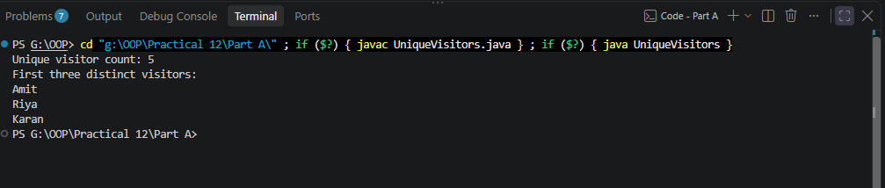

3. (For Advanced Learners – home) Build a leaderboard from player scores held in a Map and print the top-N sorted by score (ties broken by name); choose the data and sorting details.

Code:
LeaderBoard.java

import java.util.*;

public class Leaderboard {
public static void main(String[] args) {
Map<String, Integer> scores = new HashMap<>();

scores.put("Zara", 950);
scores.put("Amit", 870);
scores.put("Riya", 950);
scores.put("Karan", 720);
scores.put("Neha", 870);
scores.put("Sara", 990);

int topN = 4;

List<Map.Entry<String, Integer>> leaderboard =
new ArrayList<>(scores.entrySet());

leaderboard.sort(
Comparator
.<Map.Entry<String, Integer>>comparingInt(
Map.Entry::getValue)
.reversed()
.thenComparing(Map.Entry::getKey)
);

System.out.println("Top " + topN + " Players:");

for (int i = 0; i < Math.min(topN, leaderboard.size()); i++) {
Map.Entry<String, Integer> player = leaderboard.get(i);

System.out.println(
(i + 1) + ". " + player.getKey()
+ " - " + player.getValue()
);
}
}
}

Output:
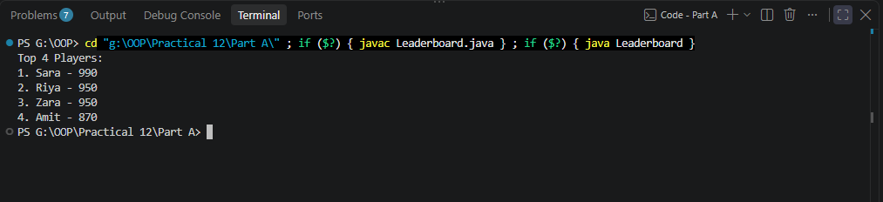

Key Questions / Analysis / Interpretation to be evaluated during/after Implementation

1. What is the difference between a List, a Set and a Map?

Ans.

Feature | Lists | Set | Map
Stores | Individual elements | Unique elements | Key-value pairs
Duplicates | Allowed | Not Allowed | Keys must be unique; values can repeat
Order | Depends on implementation; usually preserves insertion order | Depends on implementation | Depends on implementation
Access | By index | Usually by iteration or lookup | By key
Example | ArrayList, LinkedList | HashSet, TreeSet | HashMap, TreeMap

2. When do you use a HashMap versus a TreeMap?
Ans.
Use HashMap when fast key-based access is the priority and key ordering is unnecessary. Use TreeMap when you need keys sorted or operations such as finding the smallest key or retrieving a range of keys.
Note: A TreeMap can support null keys only if its comparator explicitly permits them. Its default natural ordering does not.

3. What is the difference between Comparable and Comparator?
Ans.
Feature | Comparable | Comparator
Package | java.lang | java.util
Method | compareTo() | compare()
Purpose | Defines natural ordering | Defines custom ordering
Implementation | Usually inside the class being sorted | Usually external to that class
Number of orderings | Generally one natural ordering | Multiple custom orderings are possible

